EXPERIMENT-01 DHILIPAN M
14/07/2026 192411038

8-PUZZLE PROBLEM USING BFS ALGORITHM
AIM:
To write a Python program to solve the 8-Puzzle problem using the Breadth-First Search (BFS) algorithm.

ALGORITHM:
Step 1: Read the initial puzzle state from the user.
Step 2: Define the goal state of the puzzle.
Step 3: Find the position of the blank tile (0).
Step 4: Generate all possible valid moves of the blank tile.
Step 5: Apply Breadth-First Search (BFS) to explore the puzzle states.
Step 6: Display the solution path if the goal state is reached; otherwise, display “No Solution Found”.
PROGRAM:
from collections import deque
goal=((1,2,3),(4,5,6),(7,8,0))
print("Enter the initial puzzle state:")
start=[]
for i in range(3):
start.append(tuple(map(int,input().split())))
start=tuple(start)
def find_zero(state):
for i in range(3):
for j in range(3):
if state[i][j]==0:
return i,j
def neighbours(state):
x,y=find_zero(state)
moves=[(-1,0),(1,0),(0,-1),(0,1)]
result=[]
for dx,dy in moves:
nx,ny=x+dx,y+dy
if 0<=nx<3 and 0<=ny<3:
temp=[list(r) for r in state]
temp[x][y],temp[nx][ny]=temp[nx][ny],temp[x][y]
result.append(tuple(tuple(r) for r in temp))
return result
queue=deque([(start,[start])])
visited=set()
while queue:
state,path=queue.popleft()
if state==goal:
print("Goal State Reached")
for step in path:
for row in step:
print(*row)
print()
break
if state in visited:
continue
visited.add(state)
for n in neighbours(state):
if n not in visited:
queue.append((n,path+[n]))
else:
print("No Solution Found")

OUTPUT:
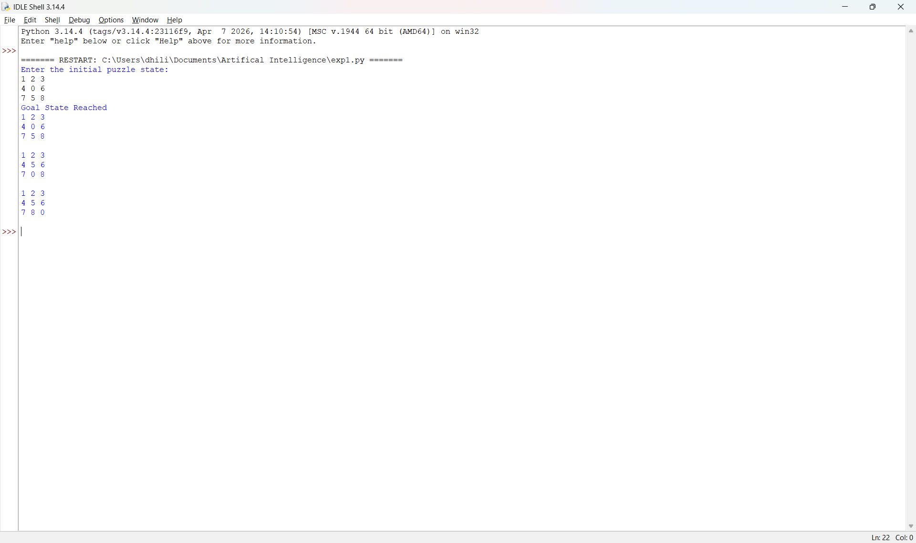

RESULT:
Thus, the Python program to solve the 8-Puzzle Problem using the Breadth-First Search (BFS) algorithm was implemented successfully and the desired output was obtained.

